Open Source Audit Report: Python
Course: Open Source Software (NGMC)
Student Name: Elizabeth Maria George
Software Choice: Python

Table of Contents
- Part A: Origin and Philosophy
  - A1: The Problem Python was Created to Solve
  - A2: The PSF License: Rights and Freedoms
  - A3: The Ethics of Community-Led Development
- Part B: Linux Footprint
  - B1: Installation and Package Management
  - B2: Key System Directories and Binaries
  - B3: Service Management via systemctl
  - B4: Security: The Importance of "Non-Root" Execution
- Part C: The FOSS Ecosystem
  - C1. Technical Dependencies & The C-Python Link
  - C2. Python’s evolution in the LAMP Stack
  - C3. Governance: The Python Software Foundation (PSF)
  - C4. Interoperability and "Glue" Logic
- Part D: Critical Analysis
- D1. Open Source vs. Proprietary (Python vs. MATLAB)
- D2. Final Verdict and Recommendations
- Part E: Shell Script Tasks
  - Script 1: System Identity Report
  - Script 2: FOSS Package Inspector
  - Script 3: Disk and Permission Auditor
  - Script 4: Log File Analyzer
  - Script 5: Open Source Manifesto Generator

Part A: Origin and Philosophy

A1: The Problem Python was Created to Solve
- The Polarized Landscape (C vs. Shell):
  - In the late 1980s, developers at the Centrum Wiskunde & Informatica (CWI) faced a binary choice for system administration.
  - The C Language: Provided high performance and "immense power" but was plagued by manual memory management, complex syntax, and frequent segmentation faults that slowed down development cycles.
  - Bourne Shell Scripts: Were efficient for quick automation but lacked the structural integrity and advanced data structures needed for complex application logic.
- The "Amoeba" Operating System Context:
  - Guido van Rossum was developing the Amoeba distributed operating system and needed a tool for administrative tasks that were too complex for shell scripts but too small to justify the time-intensive process of writing in C.
  - Python was conceived in December 1989 as a successor to the ABC language, which was readable but lacked "real-world" features like extensibility and direct kernel interaction.
- The Innovation of "Developer Happiness":
  - Python's core innovation was the philosophical shift that "Readability counts".
  - By designing the language as "executable pseudocode," it reduced the cognitive load on the programmer, moving the focus from hardware management to actual problem-solving.

A2: The License: Rights and Freedoms
- The Python Software Foundation (PSF) License:
  - Python is governed by a "permissive" license agreement designed to maximize adoption by both individual hobbyists and multi-billion-dollar corporations.
- The Four Essential Freedoms:
  - Freedom 0: The right to run Python for any purpose, whether academic, personal, or highly profitable commercial use.
  - Freedom 1: The right to study the source code (available on GitHub) and modify the interpreter's internal workings.
  - Freedom 2: The right to redistribute copies of the software to assist the global community.
  - Freedom 3: The right to distribute your own modified versions of Python to the public.
- Permissive (PSF/MIT) vs. Copyleft (GPL):
  - A critical distinction is that the GPL (Linux Kernel) is "viral," requiring anyone who distributes modifications to also share their source code.
  - The PSF license is non-viral; companies like Apple or Google can modify Python for proprietary internal products without being legally forced to release their private changes.

A3: The Ethics of the Open Source Model
- The "Corporate Parasite" Debate:
  - Trillion-dollar entities like Google and Meta build their entire AI and cloud infrastructures on Python, saving billions in research and development costs.
  - An ethical conflict exists regarding the ratio of "wealth created" to "labor donated," as the core language is still largely maintained by a non-profit foundation and volunteer community.
- Accelerating Innovation via "Public Goods":
  - Standing on the Shoulders of Giants: Libraries like NumPy and TensorFlow have democratized technology.
  - If these tools were proprietary (like MATLAB), the high cost of entry would have stalled the AI revolution; because they are open, researchers can replicate results and share code globally.
  - Open source turns software from a "private secret" into a "public good," shifting the focus of innovation from gatekeeping to collective advancement

Part B — Linux Footprint

As verified during the terminal session, the system is running Ubuntu 24.04.4 LTS with Python 3.12.3 successfully pre-installed and configured.
B1. Installation and Package Management
- The Role of APT (Advanced Package Tool): * Python was installed using the APT package manager, which is the standard for Debian-based distributions like Ubuntu.
  - APT manages the complex dependency tree of Python, ensuring that required C libraries (like libc6) and compression libraries (like zlib) are present and compatible.
  - By using sudo apt update and sudo apt install, the system maintains a "Signed" version of Python from official Ubuntu repositories, ensuring the software has not been tampered with.
- Version Control:
  - The system utilizes Python 3.12.3, which is a stable release. In Linux, python3 is often a symbolic link pointing to the specific minor version (e.g., /usr/bin/python3 -> /usr/bin/python3.12).

B2. Key System Directories and Binaries
- The Binary Path (/usr/bin/python3):
  - This is the primary executable. Placing it in /usr/bin/ ensures that it is in the system's PATH, allowing any user to run Python simply by typing the command in the terminal.
- The Standard Library (/usr/lib/python3):
  - This directory contains the core modules that make Python powerful (e.g., os, sys, json). These are read-only for standard users to prevent accidental corruption of the language core.
- Site-Packages and Local Configs (/usr/local/lib/python3.x/dist-packages):
  - This is where third-party libraries (installed via pip) reside.
  - The use of dist-packages instead of site-packages is a specific Ubuntu convention to separate packages managed by the OS from those installed manually by the user.

B3. Service Management via systemctl
- Automation and Persistence:
  - While Python is an interpreted language, scripts are often turned into Background Daemons using Systemd.
  - By creating a .service file in /etc/systemd/system/, a Python script (like a web server or a sensor monitor) can be configured to start automatically when the Linux system boots.
- Process Control:
  - Using commands like sudo systemctl start myscript.service, administrators can monitor the "health" of a Python process, view its logs via journalctl, and ensure it restarts automatically if it crashes.

B4. Security: The Importance of "Non-Root" Execution
- The Principle of Least Privilege:
  - Running a Python script as the Root (Superuser) gives that script total control over the hardware, including the ability to delete the entire file system or modify kernel memory.
- Risk of Malicious Libraries:
  - If a Python script uses a third-party library that contains a security vulnerability, an attacker could gain "Root Access" to the entire Linux server.
- Sandboxing with Non-Root Users:
  - By creating a dedicated service user (e.g., a user named python_runner) with limited permissions, we ensure that even if the Python script is "hacked," the damage is contained within that user's specific folder. It cannot touch sensitive system files in /etc/ or other users' data in /home/.

Part C: The FOSS Ecosystem

Python is frequently referred to as the "Glue Language" of the Free and Open Source Software (FOSS) world. This section explores how Python integrates with other open-source technologies and how its community-driven governance maintains its integrity.
C1. Technical Dependencies & The C-Python Link
- The CPython Implementation: * While we talk about "Python," the version installed on your Ubuntu system is actually CPython. This is the reference implementation of the language written in C.
  - Dependency on libc: CPython relies heavily on the standard C library (libc) to perform low-level tasks like memory management, file I/O, and network communication.
- The Role of GCC (GNU Compiler Collection):
  - To run efficiently on Linux, Python often needs to compile "C-extensions" (used by libraries like NumPy). This requires the GCC compiler, a cornerstone of the GNU project. This inter-dependency highlights how one FOSS project (Python) cannot exist without the infrastructure of another (GNU).
C2. Python’s evolution in the LAMP Stack
- Redefining the "P":
  - Historically, the LAMP Stack (Linux, Apache, MySQL, PHP/Perl/Python) was the foundation of the web. Originally, PHP was the dominant choice for the "P."
  - In the modern FOSS ecosystem, Python has largely taken over this role through powerful web frameworks like Django and Flask.
- Impact on Web Development:
  - Django: Follows a "batteries-included" philosophy, providing open-source tools for authentication, database management, and security out of the box.
  - Scalability: Because Python is open-source, developers have optimized it to handle massive traffic for platforms like Instagram and Pinterest, proving that FOSS tools can outperform proprietary alternatives in high-stakes environments.
C3. Governance: The Python Software Foundation (PSF)
- Institutional Support: * The PSF is a non-profit membership organization that holds the intellectual property rights behind Python. Its mission is to promote, protect, and advance the Python programming language.
  - Unlike proprietary software managed by a CEO, Python is managed by a Board of Directors elected by the community. This ensures that no single corporation (like Google or Microsoft) can "own" or "kill" the language.
- The PEP (Python Enhancement Proposal) Process:
  - Democratic Innovation: Anyone in the community can write a PEP. This is a design document providing information to the Python community or describing a new feature for Python or its processes.
  - Transparency: All PEPs are public. Before a change is made to the language (like the recent addition of "Structural Pattern Matching"), it must undergo intense public debate. This transparency is the core of FOSS ethics—decisions are made based on technical merit, not secret corporate agendas.
C4. Interoperability and "Glue" Logic
- Cross-Language Integration: * Python is the "glue" because it can easily wrap code written in C++, Rust, or Fortran.
  - In a Linux environment, Python scripts often act as the interface between high-performance system utilities and the end-user, allowing complex Linux commands to be triggered via simple, readable Python scripts.

Part D — Open Source vs Proprietary
Dimension | Python(Open Source) | MATLAB (Proprietary Alternative)
Cost | $0 (Free) | Expensive per-user licensing
Security | Peer-reviewed by thousands | "Security by obscurity" (Closed code)
Support | Massive community (StackOverflow) | Dedicated corporate support team
Freedom | Total freedom to modify core | Limited to provided toolboxes

Verdict: Based on my audit, I recommend Python for real-world deployment due to its zero-licensing cost and the massive ecosystem of libraries that prevent "vendor lock-in".
Part E: Shell Script Documentation

Script 1 (System Identity): Demonstrates variables and command substitution to pull system data.
Script 1:
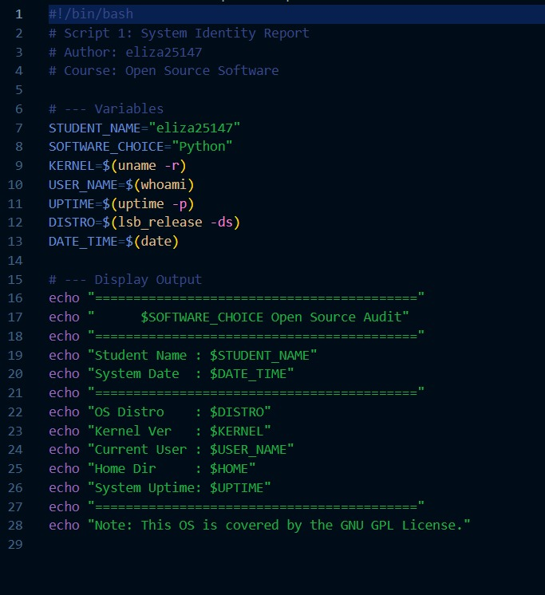

Output:
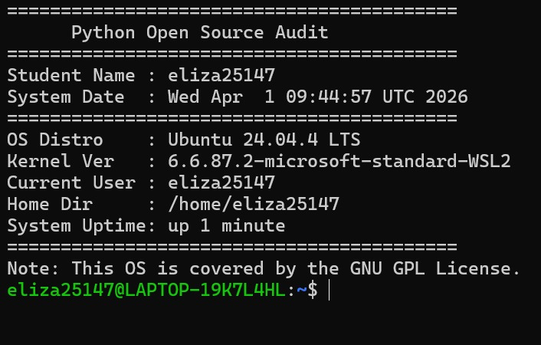
Script 2 (Package Inspector): Uses if-then-else and a case statement to audit the software installation.
Script 2:
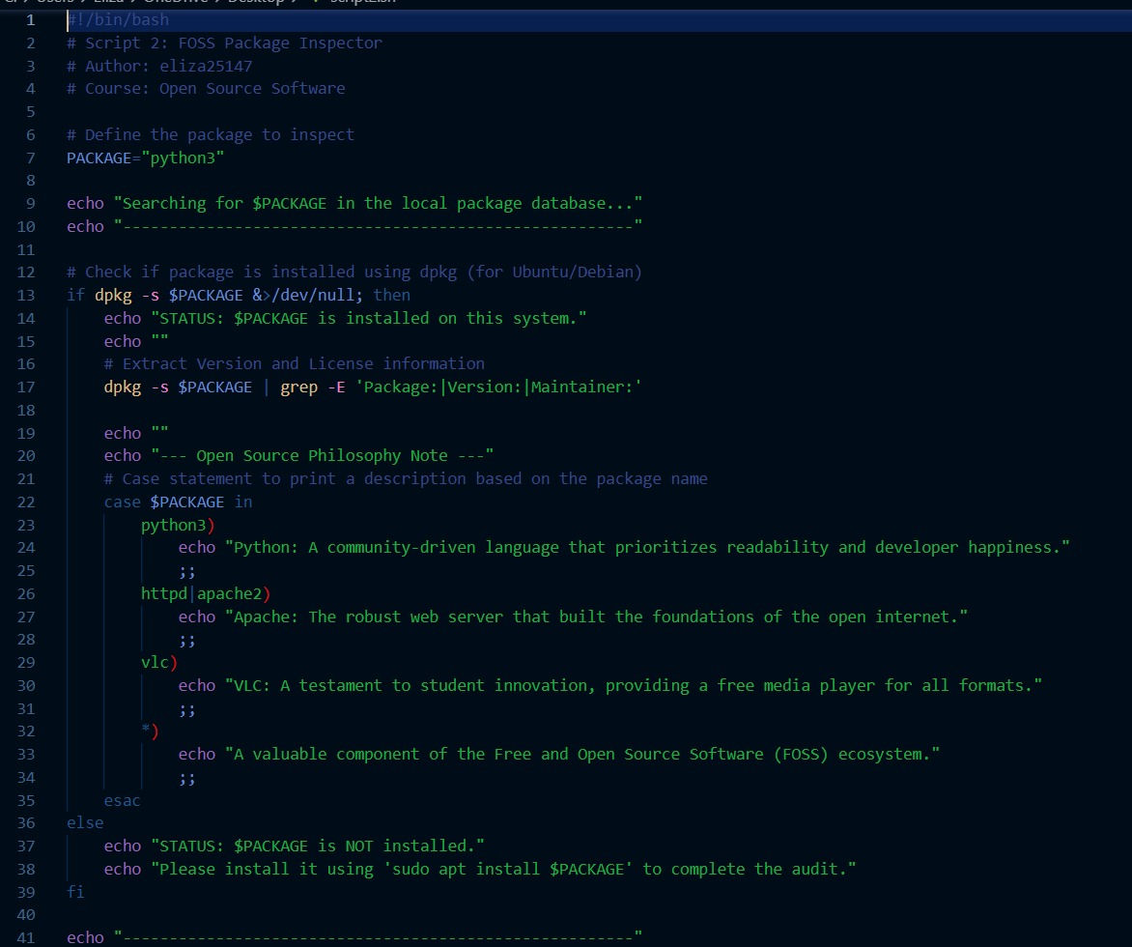

Output:
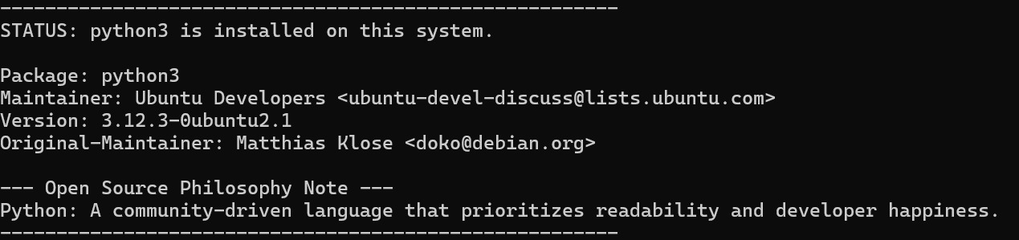

Script 3 (Disk Auditor): Utilizes a for loop to iterate through system paths and awk to format the output.
Script 3:
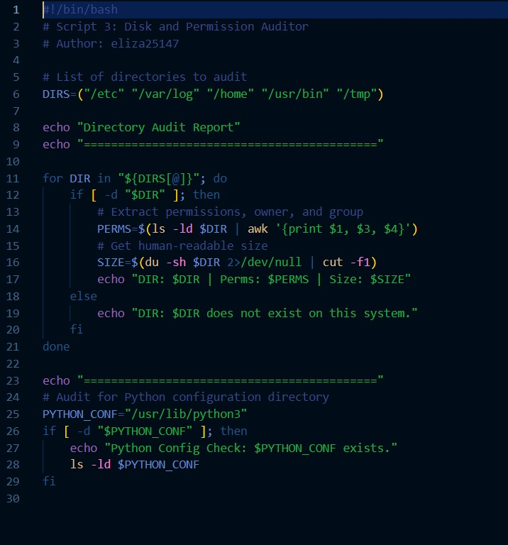

Output:
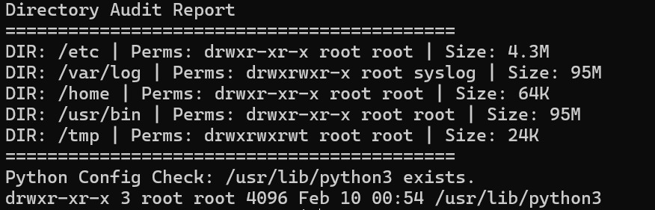

Script 4 (Log Analyzer): Implements a while-read loop to process system logs line-by-line.
Script 4:
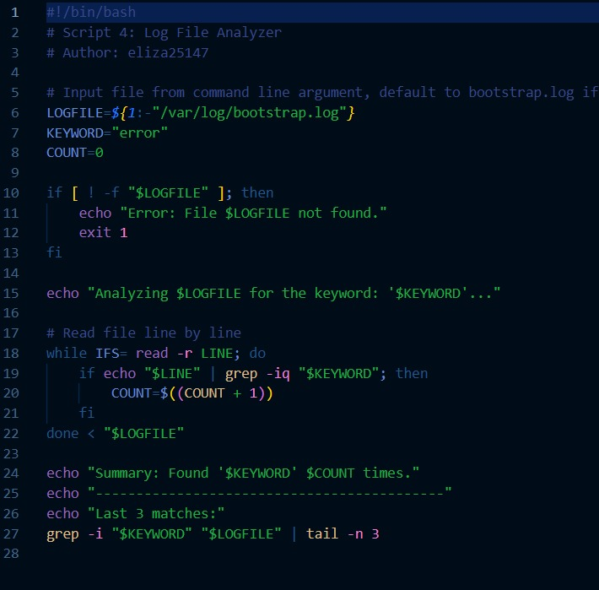

Output:
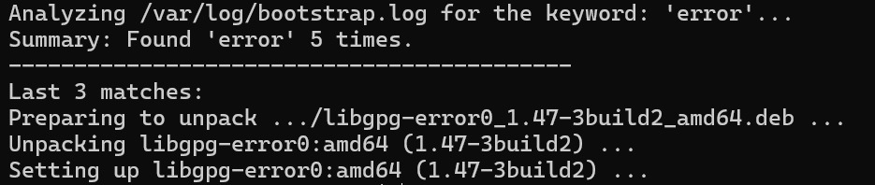

Script 5 (Manifesto): Uses interactive read commands and file redirection (>) to save data.
Script 5:
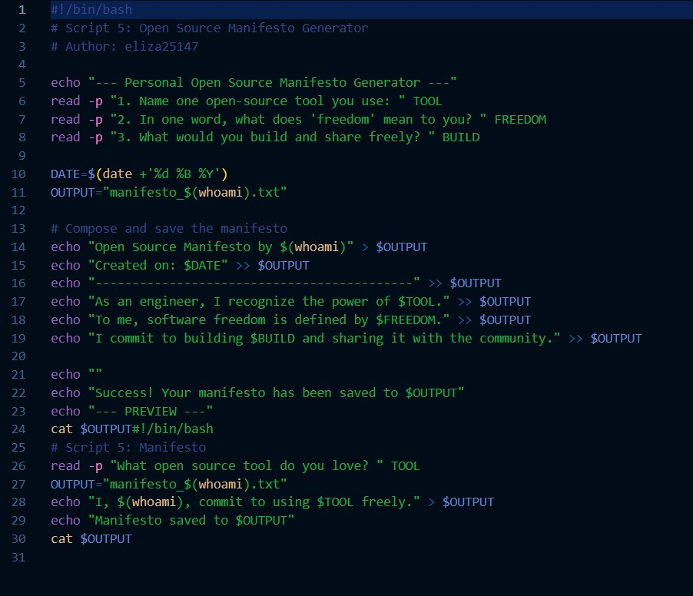

Output:
